**Introduction**

Our team is from Valley Christian High School, located in San Jose, in the Silicon Valley. At VCS, we’re studying Advanced Data Analysis, a post-AP Statistics course where we learn about fundamental concepts of statistics and skills that can be applied to evidence based research across various disciplines. In addition, we learn how to utilize statistical softwares such as Excel, JMP, and R, which played a critical role in our analysis of opioid data.

**The Opioid Epidemic**

Opioids are at the center of an unprecedented crisis sweeping our nation, with overdoses claiming the lives of more than 700,000 Americans since the late 1990s. Beginning in 1993, factors such as the overprescription of opioids and targeted marketing began contributing to rising addiction rates among Americans of all socioeconomic strata. Addiction, as defined by the CDC, is characterised by (1) opioid consumption in large quantities or long periods of time, (2) an inability to control use/a strong or recurrent desire to continue opioid use, (3) continued use despite social, personal, and physical problems directly related to opioid use, and (4) the exhibition of tolerance and/or withdrawal. As users develop a tolerance, he or she may seek a higher dose of opioid; as a result, the possibility of overdose and subsequent death by overdose rises with the quantity of opioid ingested. The opioid epidemic still continues today; in 2017, opioid overdose was ranked as the fifth leading cause of death for Americans.

**Many Factors**

We performed correlation analysis on several factors, both at county and state level. We narrowed down the data into the most significant factors: county population, county poverty rates, state HS graduation rates, and state prescription rates.

**Opioid Prescription Rates**

Surprisingly, there was very little correlation between prescription rates and overdose deaths. We obtained per-capita prescription rates for both state and county from the CDC Opioid Prescribing Rates 2016 Dataset. We expected there to be a high correlation since a higher per capita prescription should suggest higher addiction rates. However, we saw a much weaker association between addiction and overdose fatalities than what we'd expect.

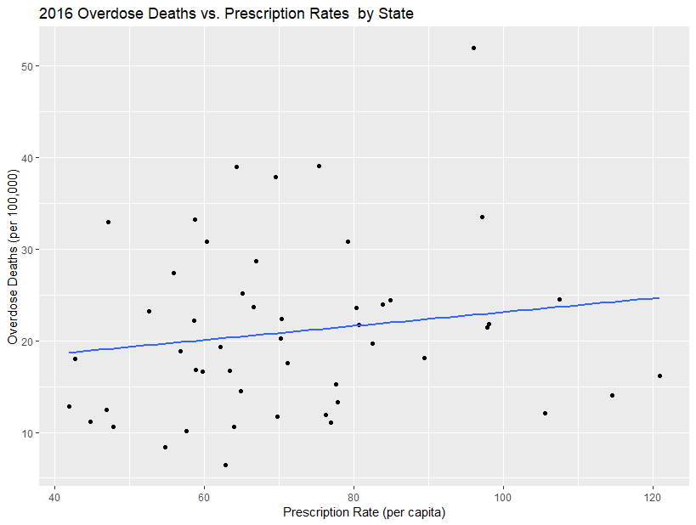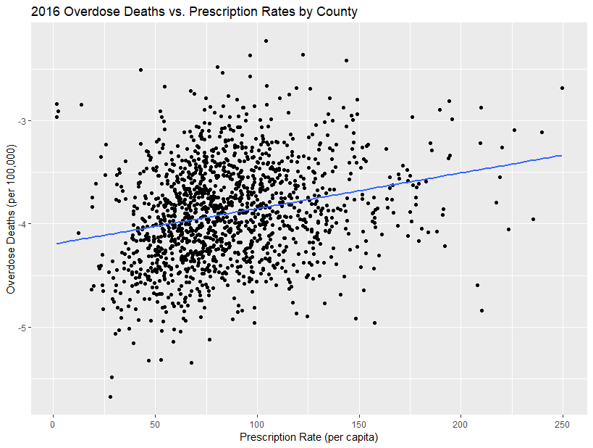

**Addiction vs. Overdose**  
 The data we analyzed was sourced from CDC WONDER dataset on drug overdose death rates. While this data helped address the issue of overdose *deaths*, it did not account for opioid *addiction rates*, as addiction rates are much more difficult to monitor and are not necessarily strongly correlated with death rates. As a result, we had a somewhat incomplete picture of the epidemic. Therefore, we chose to focus our research on preventing opioid deaths rather than preventing addictions.

There are three separate periods to deal with opioid addiction: before drug introduction, during addiction, and during life-threatening situations. Our research focuses on the latter two, since we have much more data on addiction, and preventing drug introduction would require much greater social organization and cohesiveness.

**Naloxone**

Naloxone, commonly sold as Narcan nasal spray or Evzio auto-injector, is a drug used by emergency first responders to reverse the potentially fatal damage from opioid overdose. It’s effectively a damage-control solution; it won’t prevent addiction, but it can prevent deaths that are caused by addiction.

In some states, Naloxone is available over-the-counter, allowing family members and friends to stop an overdose immediately. Coupled with Overdose Good Samaritan laws, over-the-counter naloxone access enables lay people to administer life-saving overdose reversal medication. In other states a prescription is required to purchase, making access more difficult.

We had access to 2016 data on overdose rates by state from the CDC [[2]](https://www.cdc.gov/drugoverdose/data/statedeaths.html), as well as Naloxone access laws from the Prescription Drug Abuse Policy System [[3]](http://pdaps.org/datasets/laws-regulating-administration-of-naloxone-1501695139). After running a two-sample t-test, we found statistically significant evidence (alpha level 0.005) that states with over-the-counter Narcan access at the start of 2016 had lower overdose death rates than states with prescription-only access. However, without further study, we cannot directly attribute Naloxone access to the states’ lower overdose rates since there are many potential confounding factors.

Regardless, we still recommend allowing access to naloxone over-the-counter in all states. Several studies have shown no negative effects of legalizing naloxone administration. The argument against wider naloxone access is fear that it would seemingly encourage opioid use by providing a safety net for opioid users, often saving individuals from overdose death multiple times. However, naloxone causes strong withdrawal symptoms; as a result, few addicts willingly put themselves at risk of needing naloxone. Ultimately, naloxone *can* bring back individuals from death, and it at least gives them an opportunity to turn their lives around.

**Solutions**

We see some indication that the increase in opioid overdoses can be curbed through opioid agonist therapy (OAT) and the de-stigmatization of opioid addiction treatment. OAT effectively treats drug addiction through the use of agonists such as methadone and buprenorphine, which help reduce withdrawal symptoms. Our strategy aimed at combating the opioid crisis is to overcome social stigma regarding OAT, allocate federal funding towards OAT services in crucial areas, spread the usage of Narcan, and expend leftover federal funding to expand opioid treatment throughout the U.S. To demonstrate the efficacy of OAT as a definitive solution to the opioid crisis, we will conduct a variety of statistical tests to provide statistically significant evidence.

The opioid epidemic will not be rectified by a “one-size-fits-all” solution. The states and counties most affected by the opioid epidemic span across America among diverse communities. We ran individual correlation tests between drug-related death rates and factors such as opioid prescriptions, poverty rate, education level, and population density and found very weak correlations with each. We attempted a multivariate analysis combining several of the factors and found a moderate correlation (r = 0.3426). Although this correlation is not strong enough to compel immediate action, we would like to analyze additional factors such as addiction rates, number of homeless/displaced persons in the area, age, and race/ethnicity. However, due to time constraints and limited access to databases, we were unable to do so.  
 Our solution to the opioid crisis personalizes and expedites treatment by primarily focusing on areas that are most at risk. This not only saves money through the redistribution of funds to aid more addicts, but also provides better care and treatment to patients.

**Sources**

[[1]](https://www.cdc.gov/drugoverdose/pdf/pubs/2018-cdc-drug-surveillance-report.pdf) Prescription by State

[[2]](https://www.cdc.gov/drugoverdose/data/statedeaths.html) Overdose rates by State 2016  
[[3]](http://pdaps.org/datasets/laws-regulating-administration-of-naloxone-1501695139) Naloxone Laws - 1/14/16 to 12/26/16